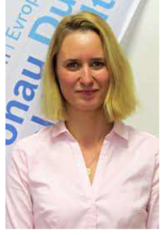
Veronika Jirkova, External Affairs and International Cooperation Section
Škroupova 18
306 13 Plzeň
Czech Republic
Tel: +420 377 195 280
E-mail: Veronika.Jirkova@plzensky-kraj.cz
Web: http://www.plzensky-kraj.cz

