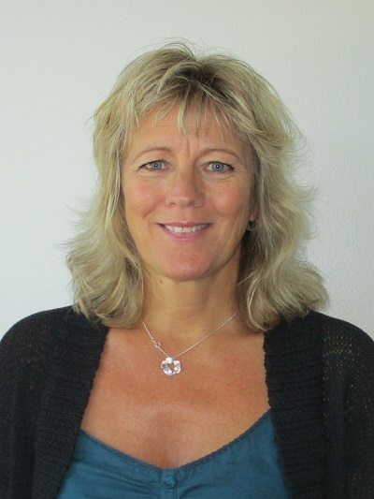
Katarina Nordmark
International strategist, International Secretariat
Värmland County Administrative Board

Mobile: +46 733-699 000
katarina.nordmark@lansstyrelsen.se
SE-651 86 Karlstad
Visiting address: Våxnäsgatan 5
Switch: +46 (0)10-224 70 00
www.lansstyrelsen.se/varmland
www.facebook.com/InternationalVarmland

